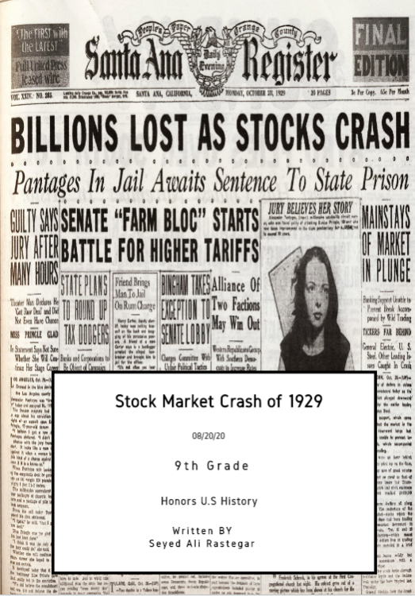

Word Count: 2117

Stocks go up and down every day. But once in a while, they systematically all crash down. One of the times that such a thing happened was in 1929. But this was no ordinary crash, it was unlike anything seen before. Even now, almost 100 years later, we have not experienced a crash to rival it. So, what led up to it? What effects did it have on people? Most importantly, what caused it? The decade that preceded the Stock Market Crash of 1929 was known as the Roaring Twenties. It was a period of opulence and bliss. Lots of new industries and household products were invented. Everything seemed great. As for the crash’s effects, they were devastating. It led to the worst depression in all of this country’s history, the highest unemployment rate in US history (“Labor Force, Employment, and Unemployment, 1929-39: Estimating Methods”) and, rampant poverty. There was a plethora of factors that ultimately led up to the vicious stock market crash in 1929. Although, I believe there were a few primary ones that had the greatest impact, such as irrational over extrapolation of rising stock prices, buying of stocks with margin (borrowed money), and companies overproducing.

# The decade that started in 1920 was commonly known as the Roaring Twenties. It was a period of abundance and economic prosperity. The wealth of the country more than doubled from 1920 to 1929 (“The Roaring Twenties History”). Credit was plentiful, and that led to many new people investing in the markets, which I will further discuss later. Lots of people moved to the cities as they picked up manufacturing in lieu of farming. For the first time, urban areas had a higher population than rural ones. Industries such as the car and plane ones boomed with the help of many new inventions. To put it into perspective, in 1918 only 1/13 families owned a car. By 1929, 4/5 families had one (“Kyvig 27 “).

Despite how contradictory it is to common sense and history, at the time, it was extensively believed that the run-up in stocks which had took place during the Roaring Twenties, also known as a bull market, would continue to ascend indefinitely. And people didn’t only believe this notion, they acted on it. Many invested their entire life savings into the market, without adequate hedging. Hedging is an investment technique that allows one to lessen potential losses in their investments by purchasing a second investment that is expected to perform in the opposite way (“Hedge”). But after all, why would they even hedge? The people of the time believed a downfall would and could never come. As F. Scott Fitzgerald wrote in Echoes of the Jazz Age, “Until that time, American life seemed fundamentally sound. The typical American was still hardworking and sensible. The coming storms lay unseen beyond the horizon as the twenties roared on” (10).

The second primary reason that led to the crash, was the purchasing of stocks on margin. Margin means borrowing money from your brokerage firm to invest in stocks, with the invested money serving as collateral (“Buying on Margin Definition.”). Buying on margin can amplify returns when stocks go up. Let me give an example to illustrate this practice. Imagine an investor has $10,000 to invest. They buy a stock of a company and it goes up by 30%. The investor now has $13,000. But now imagine if instead the investor tapped into margin and borrowed another $10,000 from his brokerage and invested that in addition to his own $10,000 in that same stock. Once it goes up by 30%, he will have $26,000. He sells it all and gives back the $10,000 to his broker. Now, he made double the profit and has $16,000. With abundant access to credit, as people saw the market only reaching new record highs day after day, they loaded up on stocks with lots of margin to amass the best possible return. And they did for a while. The Dow-Jones Industrial Stock Price Index for the United States rose almost 500% from 1920 to September of 1929 (“Dow-Jones Industrial Stock Price Index for United States”). Many individual companies’ stocks even had far higher returns than that as well. Leveraged up with margin, many investors struck fortunes and garnered levels of wealth more copious than their most ambitious dreams, all in the span of a few years. Margin seemed glorious while things went up, but once they stopped, things became extremely ugly.

The third primary reason that led to the Stock Market Crash of 1929, was companies overproducing (“Causes of the Great Depression.”). With lots of credit and technological innovation, businesses were able to increase their output by significant amounts. They borrowed lots of money to finance new factories. And during the boom, people consumed all of this production, many of them financing it through the taking on of debt. But soon, the people could no longer keep on raking up so much debt and they had to slow their consumption down. Companies had also bet on being able to export their goods to Europe. But as congress saw consumption of goods slowing down, they passed the **Fordney–McCumber Tariff** in 1922. They believed this would help businesses out. But in retaliation, America’s trading partners passed their own tariffs on America. France for example, raised its tariff on automobiles from America to 100%, when it had previously been 45% (Rothgeb 32-33). So as a tariff war ensued, businesses’ plans of being able to export could no longer reach fruition.

Overproduction was an issue in farming as well. To keep up with the demand in World War 1, many farmers innovated and reinvested their profits to be able to increase their supply of crops. But after the war, demand fell. As a result, crop prices plummeted, and many farmers could no longer operate at profitable levels. In addition to companies, farmers had also bet on being able to export their crops to Europe. But European farmers innovated and were growing their own crops, so they had less need for American ones. Also, the aforementioned tariffs passed by America caused retaliatory tariffs on agriculture as well. That further hampered farmers’ ability to export.  As a result of the tariffs, according to the American Farm Bureau, farmers lost more than $300 million annually (Kaplan 2-8).

So, as we can see, there were many preconditions during the Roaring Twenties that led to the inevitable crash of the stock market in 1929. Nonetheless, people ignored the associated dangers and risks and simply kept investing. But cracks in the foundation of the market began emerging. On October 24 1929, dubbed Black Thursday, the stock market dropped 11% right as it opened due to heavy selling.

Bankers were worried about the decline, so they met together to contrive a solution (Goldston 39-40). With all their resources, they decided to pump money into the market. They placed buy orders for many of the major stocks at prices a lot higher than what they were currently selling at. Their efforts were successful as the market recovered most of its losses. The Dow Jones Industrial Average ended up closing down only 6.38% that day (“Dow-Jones Industrial Stock Price Index for United States”).

Friday the next day, the market rallied upwards. Things were looking promising. But the next day of trading, known as Black Monday, the market steeply declined by 12.82% (“Dow-Jones Industrial Stock Price Index for United States”). As I previously established, many people had invested with margin. When the value of their assets declined, their brokers issued them margin calls. Margin calls happen when the value of an investor’s positions with margin declines, and their broker subsequently requires them to deposit additional money into the account so they can meet the minimum value they need to have margin. If the investor fails to meet this demand, the broker sells the investor’s positions instead. So as the market fell on Black Monday, many investors were met with margin calls (“The Stock Market Crash That Launched the Great Depression”). But they did not have any additional money to give to their brokers, so the brokers sold their stocks. This further drove down the prices of stocks which caused more people to be met with margin calls who then also had to sell, leading to a vicious self-perpetuating downward spiral of stock prices.

The next day on October 29, 1929, known as Black Tuesday, stocks plummeted another almost 12% (“Dow-Jones Industrial Stock Price Index for United States”). The roaring twenties had come to a halt. The decade long prosperity was over, and the days of the Great Depression had begun. With it, came a banking crisis as well. People realized that banks had also invested a lot of their deposits into the stock market. And since the values of the stocks had declined, they had lost lots of money, and as a result they could not give back people all of their money. This realization led to a massive panic, and people started withdrawing their deposits from banks everywhere. Banks could not meet all the deposits requested, and they went bankrupt. This caused even more panic, which led to even more failures.

The economy was in complete shambles. As banks failed, the businesses could not acquire the funds they needed to operate. That caused them to have to fire many of their workers. This, along with the money lost in the stock market, weakened demand for products significantly. Companies had overproduced, and now demand was a fraction of what it used to be. That caused many of them to declare bankruptcy as they could not bring in enough revenue to pay back their debts. That caused even more banks to fail, and their stock prices to decline even lower, all of which caused more and more harm and strain to the economy and to regular people.

As I said at the beginning, it is common for stocks to rise and fall every day. But occurrences like the Stock Market Crash of 1929, where everything steeply crashes down all of a sudden, are far from common. There were a lot of different factors that ultimately led to it, but from my analysis, I have concluded that the primary ones were: irrational over extrapolation of rising stock prices, buying of stocks with margin (debt), and companies overproducing. It all started with the decade before the crash, dubbed the Roaring Twenties. It was a prosperous time, and people were optimistic- too optimistic. They believed the prosperity would continue on forever and it caused them to make irrational choices. As the stock market rose, people assumed it would rise forever. They believed this to such an extent that they borrowed large sums of money to invest. And companies thought people would keep buying their goods forever, so they also borrowed to produce more things. But eventually, the market crashed, and everything collapsed. Banks went out of business as people rushed to get their money and businesses couldn't pay back their loans. People lost their jobs, and went deep into debt as they also could not pay back the money they borrowed to invest. The country was plunged into the worst depression in its history, and even to this day, we have not one to rival it. That is the story of the great depression, and what caused it. Hopefully, humanity has learned from its mistakes, and an event like the Stock Market Crash of 1929 and the subsequent Great Depression will never be repeated. But alas, one can only hope.

**References**

Amadeo, Kimberly. “The Stock Market Crash That Launched

the Great Depression.” *The*

*Balance*, [www.thebalance.com/stock-market-crash-of-](http://www.thebalance.com/stock-market-crash-of-)

1929-causes-effects-and-facts- 3305891

*American Trade Policy, 1923-1995*, by Edward S. Kaplan, Greenwood, 1996, pp. 2–8.

“Causes of the Great Depression.” *History Learning*, historylearning.com/modern-world-

history/america-1918/causes-of-the-great-depression/

Chen, James. “Buying On Margin Definition.” *Investopedia*, Investopedia, 22 May 2020,

www.investopedia.com/terms/b/buying-on-margin.asp

“Dow-Jones Industrial Stock Price Index for United States.” *Federal Reserve Bank of*

*St. Louis*, 15 Aug. 2012,

www.fred.stlouisfed.org/series/M1109BUSM293NNBR

Fitzgerald, F. Scott. *Echoes of the Jazz Age: Short Story*. Les Productions Luca, 2015.

History.com Editors. “The Roaring Twenties History.” *History.com*, A&E Television

Networks, 14 Apr. 2010, [www.history.com/topics/roaring-twenties/roaring-twenties-](http://www.history.com/topics/roaring-twenties/roaring-twenties-)history

Kyvig, David E. *Daily Life in the United States, 1920-1940: How Americans Lived through the*

*"Roaring Twenties" and the Great Depression*. Ivan R. Dee, 2004.

Lebergott, Stanley. “Labor Force, Employment, and Unemployment, 1929-39: Estimating

Methods.” *U.S. BUREAU OF LABOR STATISTICS*, July 1948,

[www.bls.gov/opub/mlr/1948/article/pdf/labor-force-employment-and-](http://www.bls.gov/opub/mlr/1948/article/pdf/labor-force-employment-and-)

unemployment-1929-39-estimating-methods.pdf

Reiff, Nathan. “Hedge.” *Investopedia*, Investopedia, 24 July 2020,

www.investopedia.com/terms/h/hedge.asp

*The Great Depression: the United States in the Thirties*, by Robert Goldston, Ballantine,

1984, pp. 39–40.

*U.S. Trade Policy: Balancing Economic Dreams and Political Realities*, by John M. Rothgeb,

CQ Press, 2001, pp. 32–33.